Term | Theme | Sub questions | Subject Specific Vocabulary | Linked Visits in / Visits out/Experiences/Stories | Assessment will be based on a formative approach of children being able to answer the key questions using the knowledge acquired over the half term through a quiz-based approach.
Autumn Term A  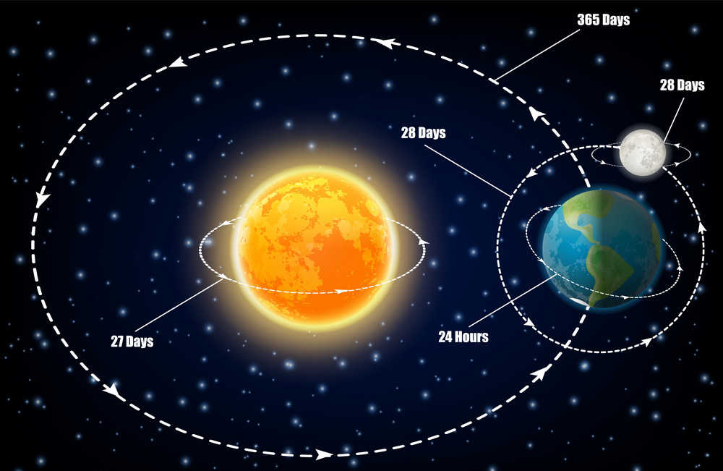 | Sun, Moon and Earth  Physics | Why are Sun, Earth and Moon spherical?  What are the planets in our solar system?  How does Earth and other planets move in relation to the sun?  How do we get day and night?  Why does shadow size change over the course of the day?  Know that the Sun, Earth and Moon are approximately spherical.  Know what the planets in our solar system are made up of.  Know the order of the planets in our solar system.  Know the Earth revolves around the sun (365 days).  Know the tilt of the earth whilst revolving gives us seasons.  Know that the sun is not moving across the sky.  Know that day and night are caused by the earth’s rotation.  Know that the moon’s movement dictates its phases. | Axis  Rotation  Orbit  Spherical  Solar System | Tim Peake  Neil Armstrong  Katherine Johnson  Space Centre  Hidden Figures - Movie  The way back home – Oliver Jeffers
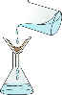  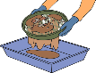  Autumn Term B | Materials Mixtures and Separation  Chemistry | What are mixtures?  How can we separate mixtures?  What does dissolve mean?  Which sweets will dissolve in water?  How can we clean dirty water?  Know about reversible and irreversible changes.  Know that some changes can be reversed and some cannot.  Know that you can filter, sieve or evaporate to separate mixtures.  Know how to recover a substance from a solution. | Reversible  Irreversible  Filtering  Sieving  Dissolve | Whitby – coastal erosion  Reversible / Irreversible changes workshop
Spring Term A   | Forces in action  Physics | What is gravity?  How was gravity discovered?  How do we measure a force?  Why does the length of a piece of paper affect the time it takes to fall?  How does the saltiness of the water affect the water resistance?  Know that Gravity is a force that attracts objects towards earth.  Know how Gravity was discovered (Isaac Newton)  Know that other forces can act against gravity to slow or quicken an objects movement. (air resistance, water resistance)  Know the effects of water resistance (Balloon Push) | Air Resistance  Water Resistance  Gravity  Newton Metre  Balanced/Unbalanced | Isaac Newton
Spring Term B  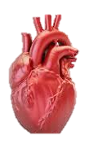 | Keeping Healthy  Biology | How can we keep our heart and body healthy?  How does our heart work?  Why do we have blood?  I know that the heart is the main organ in the circulatory system.  I know how the heart, blood vessels and blood works. (atriums and ventricles)  I know how nutrients are transported around the body.  I know how to keep the heart and body healthy. (diet and exercise)  I know that drugs, alcohol and smoking has a negative impact on the heart and body. | Oxygenated  Deoxygenated  Circulatory System  Artery  Veins
Summer Term A    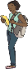  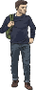    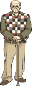  fertilisation  infancy  puberty  childhood  early adult  middle age  old age | Our Changing Bodies  Biology | How do humans change throughout their lives?  What causes puberty?  Are there any patterns between vertebrate animals and their gestational periods?  Know about how our bodies will change and develop from birth to old age. For example: height, physical abilities  Know that puberty is something that happens to us all. For example: Sexual organs develop  Know that life expectancy is different across species.  Know that gestation periods vary across species. | Gestation  Puberty  Life Expectancy  Hormone  Foetus | Babette Cole – Hair in Funny Places
Summer Term B  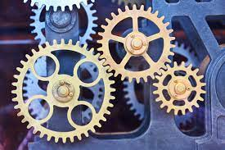 | Forces – Mechanisms  Physics | What is the most effective way to move an object?  How can we use levers to lift heavy objects?  How can we use pulleys to lift heavy loads?  Know that some objects require large forces to make them move.  Know that some mechanisms can reduce the force needed to make things move. (gears, levers and pulleys) | Levers  Gears  Pulleys  Mechanism  Machine | Vex Robotics  STEM project

