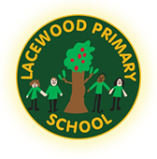
Lacewood Primary School

Keeping You Safe!
(Our Child-Friendly Safeguarding Guide)

💛 Our Promise
Everyone at Lacewood wants you to feel happy, safe, and looked after every day. If you ever feel worried, scared, or unsafe, please tell an adult – we will listen and help.

👩‍🏫 Who Can You Talk To?
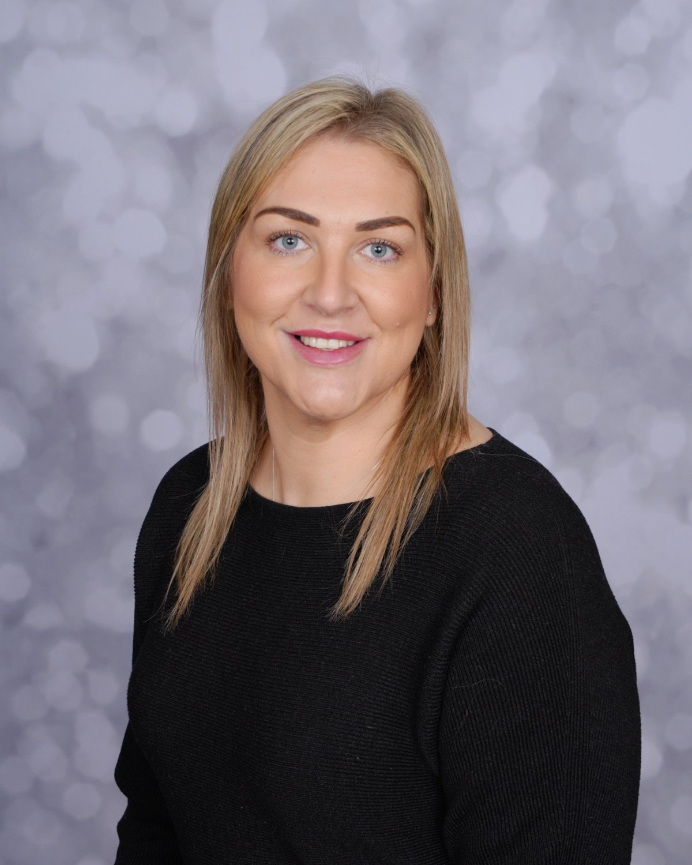
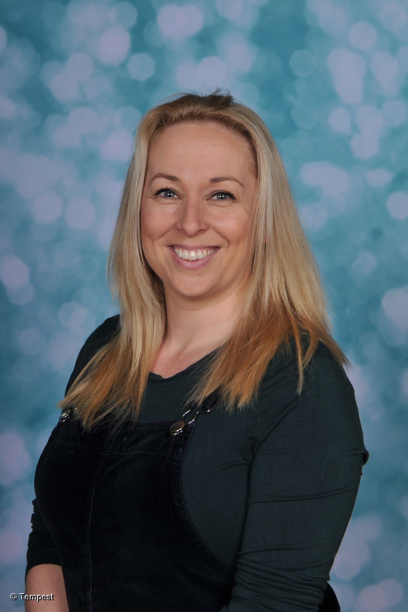

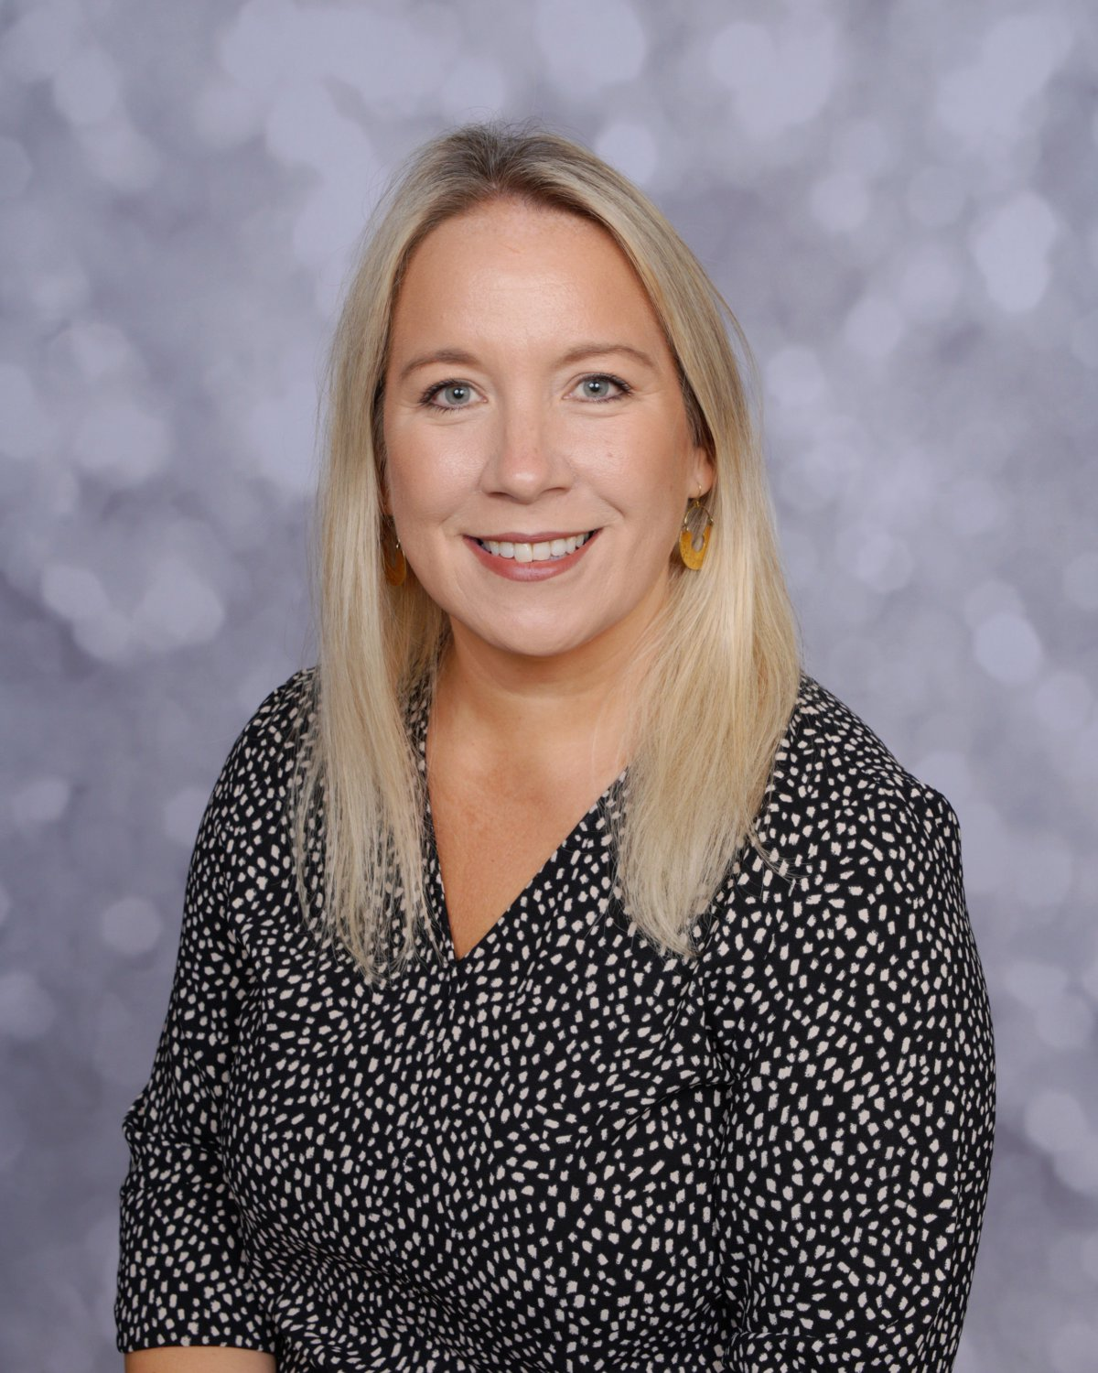
You can talk to any adult in school — teachers, teaching assistants, lunchtime staff, or office staff.
You can also talk to our Safeguarding Team:
- Miss Akeroyd – Designated Safeguarding Lead
- Mrs Searle – Deputy DSL
- Mrs Anson – Deputy DSL
- Mrs Jackson – Well-being Lead
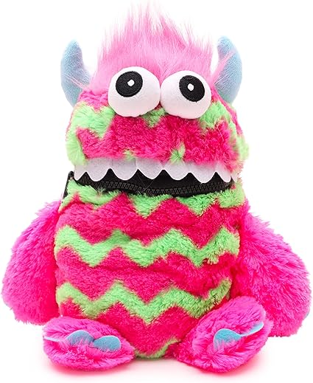
Or, you can use your classroom or the Thrive Room worry monster if it’s easier to write it down.

💬 Tell Us If…
• Someone is hurting you or being unkind
• You feel scared or worried about something
• Someone is touching you in a way you don’t like
• You see or hear something online that upsets you
• Someone asks you to keep a secret that makes you uncomfortable
• Something is happening at home that makes you sad or worried
Nothing is ever too small. If it worries you – it matters.

🛡 What We Will Do
• We will listen carefully.
• We will believe you.
• We might need to tell another grown-up so we can help.
• We will never be cross with you for speaking up.
• We will help you feel safe again.

📱 Staying Safe Online
✅ Keep your name, address, and passwords private.
✅ Tell a grown-up if something online makes you feel upset.
✅ Never talk to or meet up with strangers online.
✅ Think before you share photos or messages.

🤝 Be Kind, Be Respectful
We are a kind and caring school.
Let’s make sure everyone feels:
🌈 Safe 💬 Listened to 🤗 Included
If you see someone being unkind, tell an adult — you can help keep everyone safe!

🌟 Remember
If something doesn’t feel right,
Tell a trusted adult straight away.
You will never be in trouble for asking for help.
“Speak up, stay safe, and look after each other.”

